AIRBNB Case Study IIIT-B MD Abubakar, Devanshi Gupta and Sachin Godage
In the case study we have used Jupiter notebook to perform initial analysis of the data and Tableau for data analysis and visualization.
Initial Analysis using Jupiter Notebook: Data Set Used: AB_NYC_2019.csv
Number of Rows: 48895

Number of Columns: 16
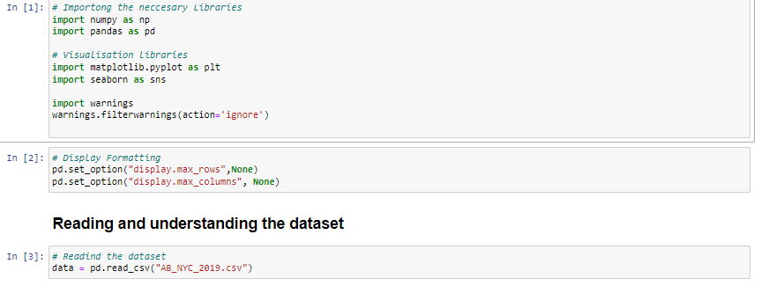

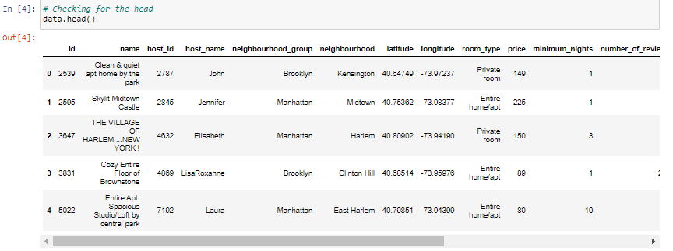
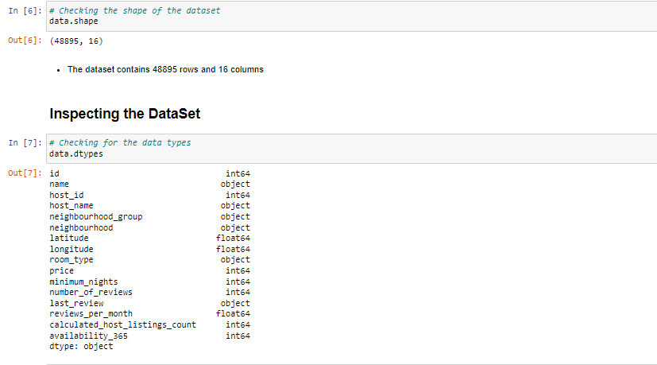
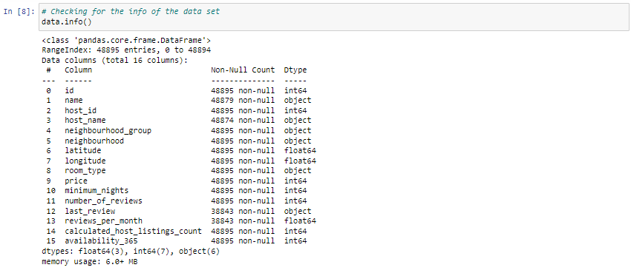
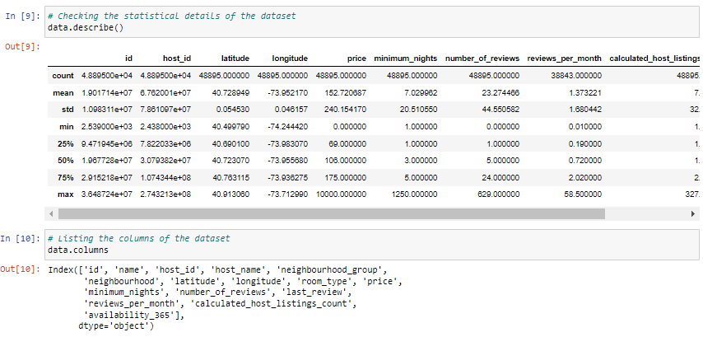

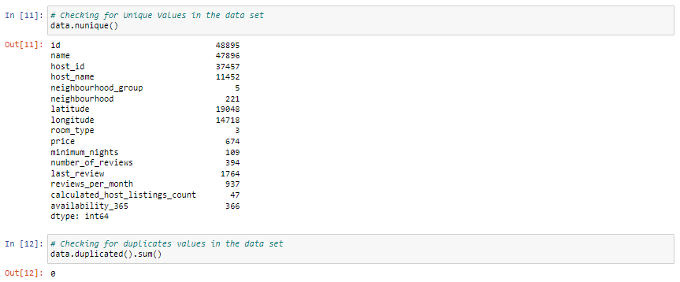

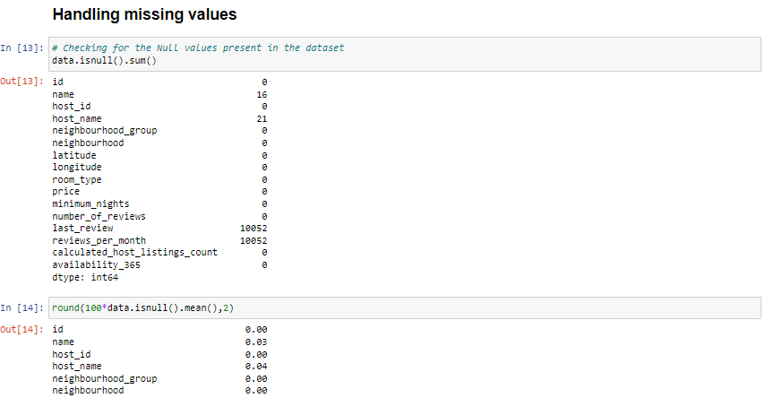

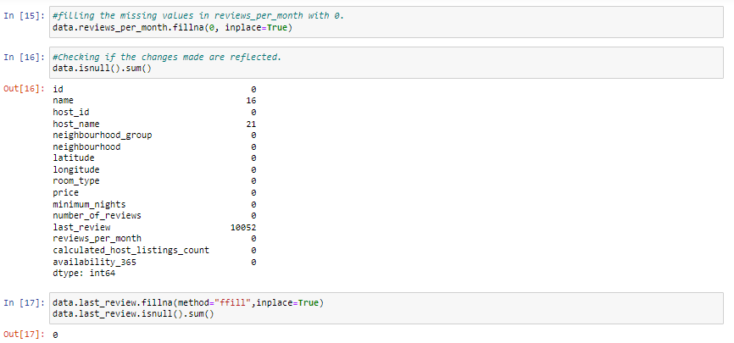
- We have imputed the missing values.

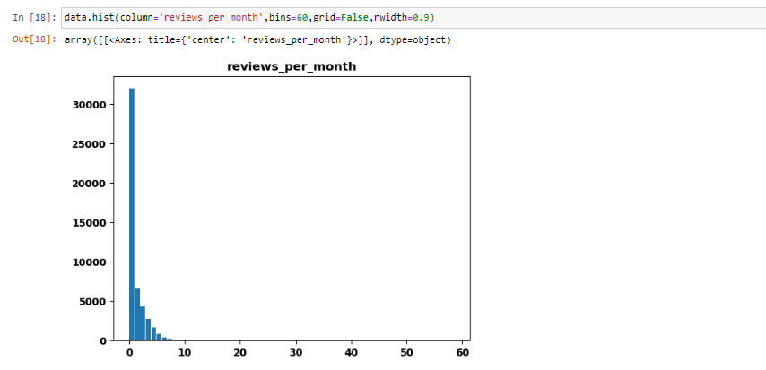

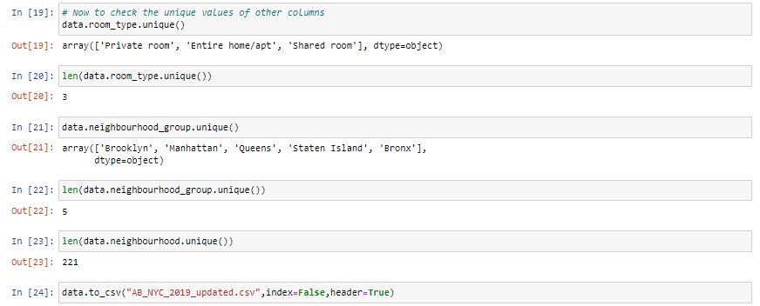

Step 2: Data Wrangling:
- Checked the Duplicate rows in our dataset and no duplicate data was found.
- Checked the Null Values in our dataset. Columns like name, host-name, last review and review-per-month have null values.
- We have made missing value imputation to the columns.
- Checked the formatting in our dataset.
- Identified and review outliers.

Methodology Document PPT 1:

Data Analysis and Visualizations using Tableau:
We have used tableau to visualize the data for the assignment. Below are the detailed steps used for each visualization.

Top 10 Host:
  - We identified the top 10 Host Ids, Host Name with count of Host Ids using the tree map.

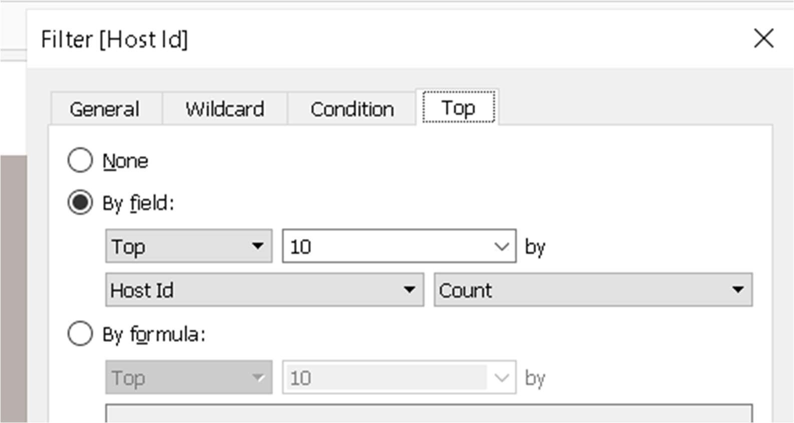

Preferred Room type with respect to Neighbourhood group:
  - We created a pie chart for understanding the percentage of room type preferred w r t neighbourhood group
  - We added Room Type to the colours Marks card to highlight the different Room Type in different colours and count of Host Id to the size

For Variance of price with Neighbourhood Groups:
- We used a box and whisker’s plot with Neighbourhood Groups in Columns and Price in Rows.
- We changed the Price from a Sum Measure to the median measure.

Average price of Neighbourhood groups:
- We created a bubble chart with Neighbourhood Groups in Columns and Price column in Rows.
- We added the Neighbourhood Groups to the colors Marks card to highlight the different neighbourhood Groups in different colors. Also Put Avg price in Label.

Customer Booking w r t minimum nights:
- We created the bin for Minimum nights as shown below.
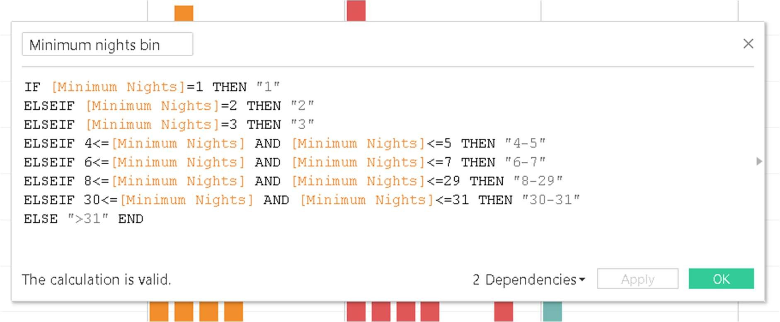
- The bins were used to display the distribution of minimum nights based on the number of ids booked for each neighbourhood group.

Popular Neighborhoods:
- We took neighbourhood in rows and sum of reviews in column and took neighbourhood groups in colour.
- We used filter to show Top 20 neighbours as per the sum of reviews.

Neighbourhood vs Availability:
- We created a dual axis chart using bar chart for availability 365 and line chart for price for top 10 neighbourhood group sorted by price.

Methodology Document PPT 2:

Room type with respect to Neighbourhood group:
  - We created a pie chart for understanding the percentage of room type preferred w r t neighbourhood group
  - We added Room Type to the colours Marks card to highlight the different Room Type in different colours and count of Host Id to the size

Customer Booking with respect to minimum nights:
- We created the bin for Minimum nights as shown below.
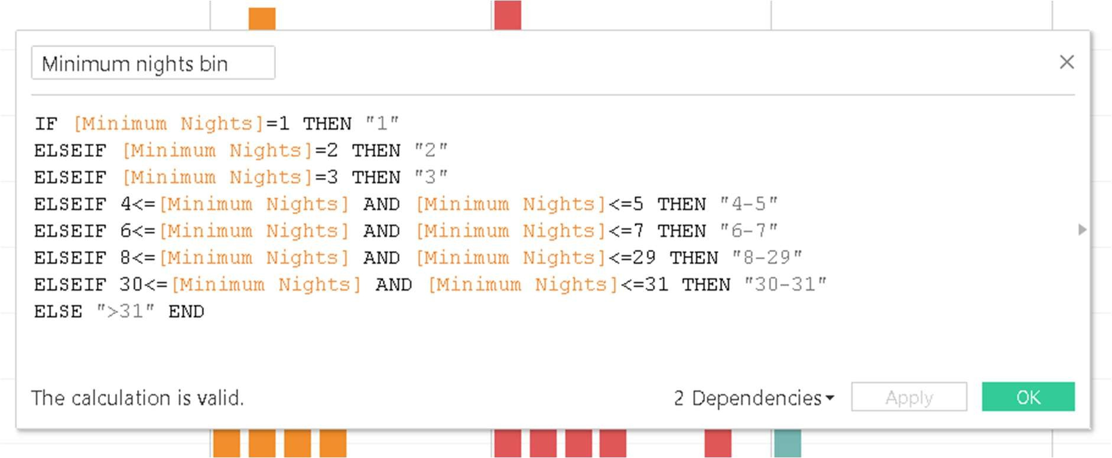
- The bins were used to display the distribution of minimum nights based on the number of ids booked for each neighbourhood group.

Neighbourhood vs Availability:
- We created a dual axis chart using bar chart for availability 365 and line chart for price for top 10 neighbourhood group sorted by price.

Price range preferred by Customers:
- We have taken pricing preference based on volume of bookings done in a price range and no of Ids to create a bar chart. We have created bin for Price column with interval of $20.

Understanding Price variation w.r.t Room Type & Neighbourhood:
- We created Highlights Table chat by taking Room Type in rows & Neighbourhood Group in column.
- We took the average price in colour Marks card to highlight the different Room Type in different colours.

Price variation w r t Geography:
- We used Geo location chart to plot neighbourhood, neighbourhood Group in map to show case the variation of prices across.

Popular Neighborhoods:
- We took neighbourhood in rows and sum of reviews in column and took neighbourhood groups in colour.
- We used filter to show Top 20 neighbours as per the sum of reviews.

Tools used:
- Data cleaning and preparation: Jupyter notebook – Python
- Visualization and analysis: Tableau
- Data Storytelling: Microsoft PPT

